**Troubleshoot Ethernet Communication with ping and traceroute -> Using cisco packet tracer**

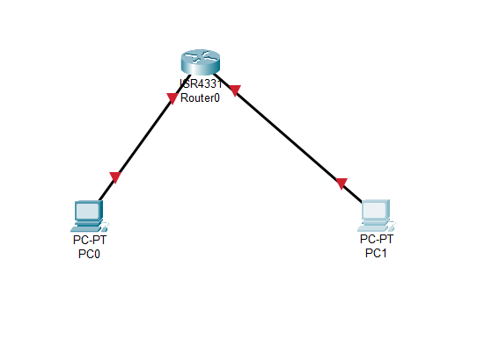

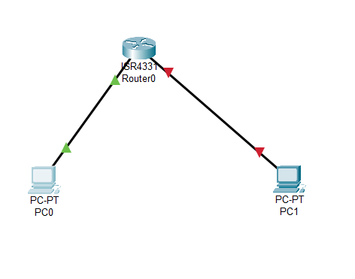

**Cannot able to ping PC1🡪PC2:**

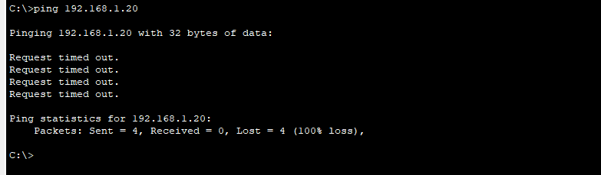

**Traceroute:**

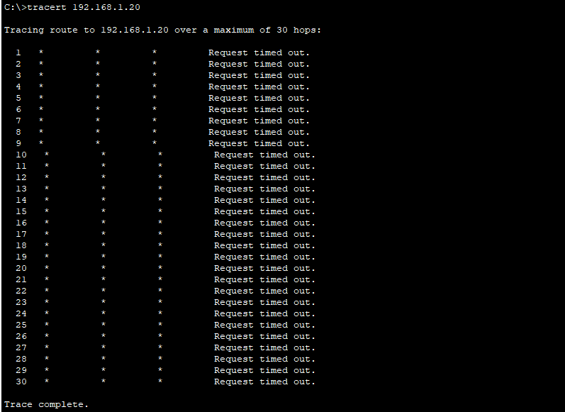

**Fixed the Connectivity and misconfiguration Issue:**

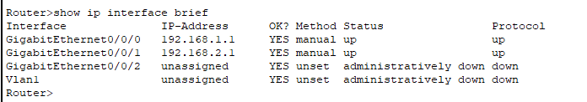

**Pinging Done:**

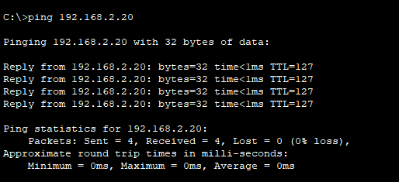

**Observation:**

* Initially, PC1 could not ping PC2, indicating a connectivity issue.
* Traceroute was used to diagnose the problem, likely revealing where the packets were getting dropped.
* The issue was identified as a misconfiguration, which was then fixed.
* After troubleshooting, ping was successful, confirming that the network was properly configured.